**Obtaining a Certificate for RDP Access**

Create a certificate request from any server using IIS7 Manager

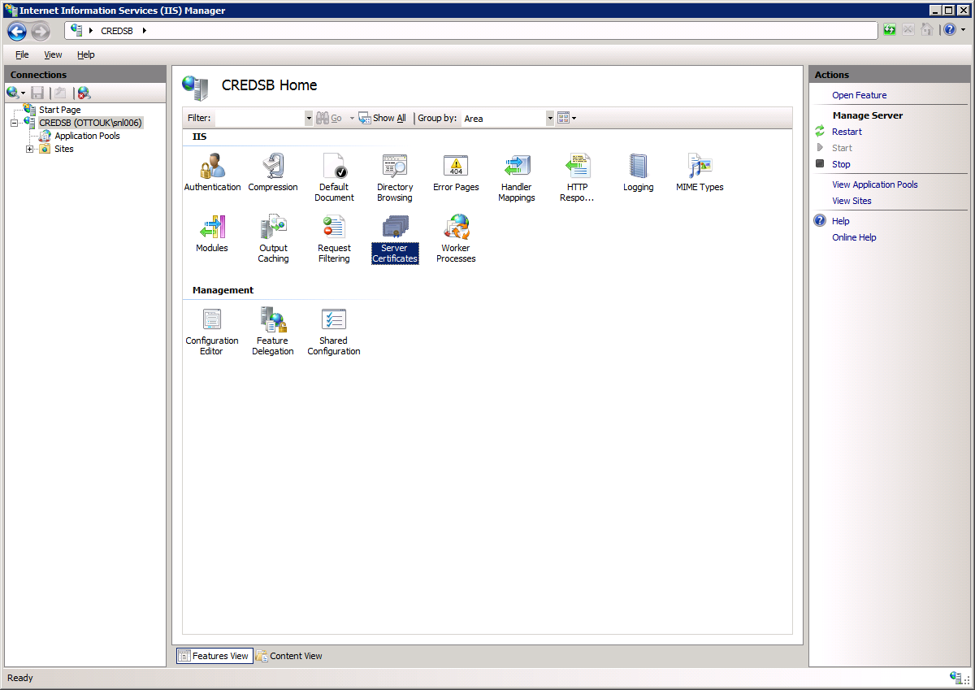

Click on Create Certificate request.

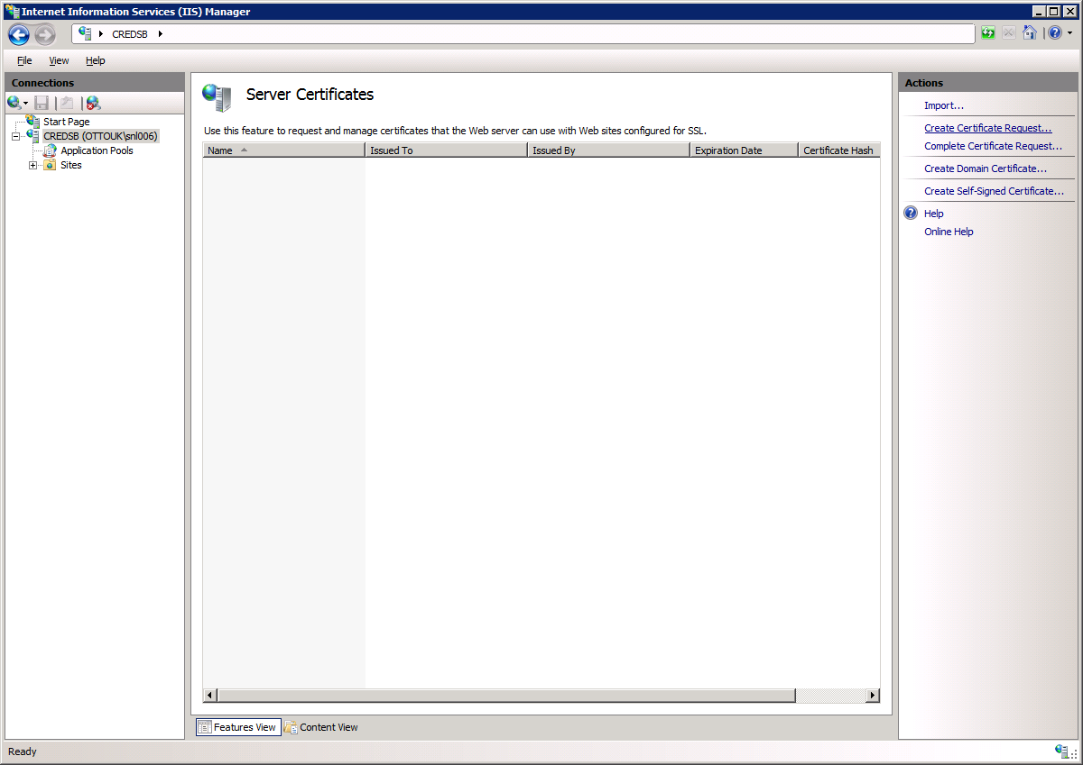

This launches the wizard. Rule of thumb...Use the fqdn.

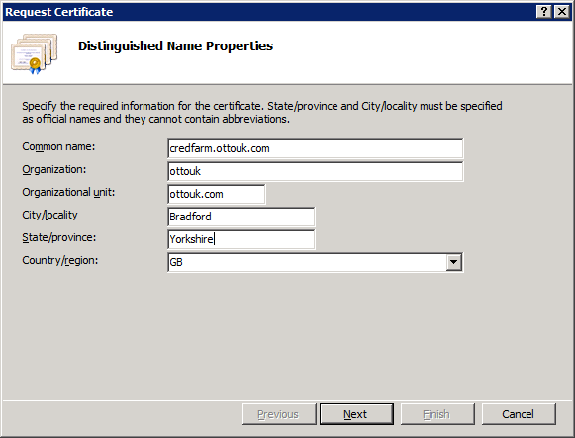

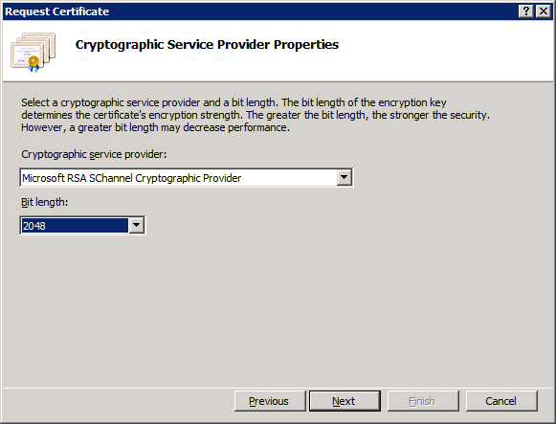

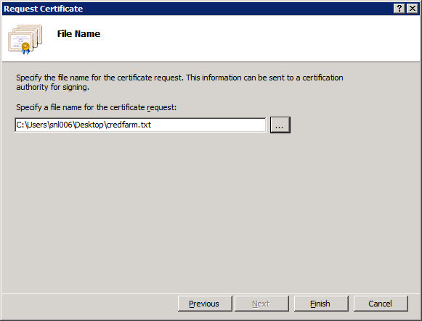

Save as a txt file. Copy the text.

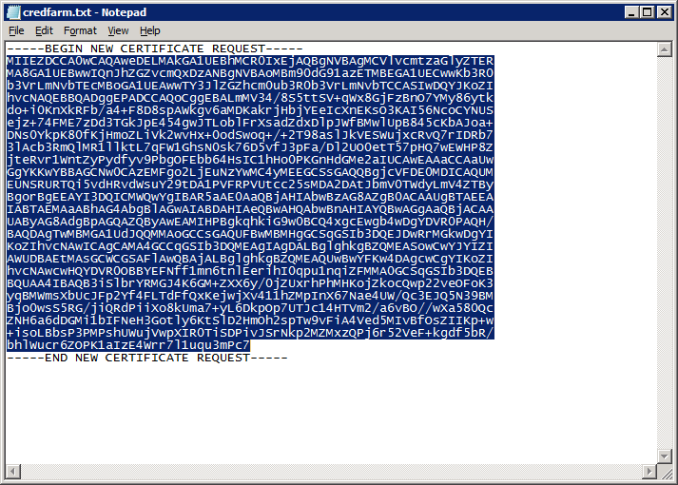

Go to <https://ca1/certsrv>

Click on Request a Certificate.

Submit an advanced certificate request

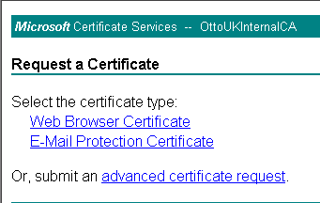

|  |
| --- |
| Click Submit a certificate request by using a base-64-encoded CMC or PKCS #10 file, or submit HYPERLINK "certrqxt.asp"a renewal request by using a base-64-encoded PKCS #7 fileHYPERLINK "certrqxt.asp".  Paste the text you copied earlier. Then Submit. |
|  |

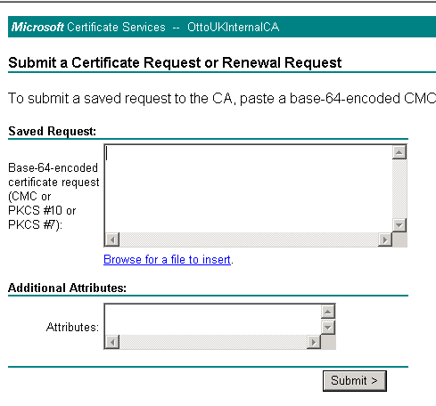

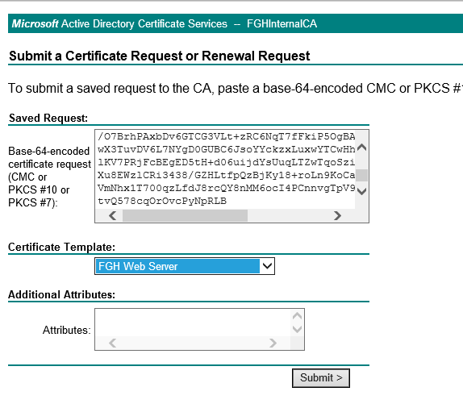

You will then get a message about your request awaiting an administrator....

|  |  |
| --- | --- |
| ***Microsoft*** Certificate Services -- OttoUKInternalCA | **Home** |

**Certificate Pending**

|  |
| --- |
|  |

Your certificate request has been received. However, you must wait for an administrator to issue the certificate you requested.

Your Request Id is 56.

Please return to this web site in a day or two to retrieve your certificate.

**Note:** You must return with **this** web browser within 10 days to retrieve your certificate

You can then view the status of a pending certificate.

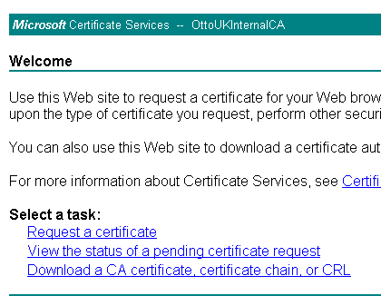

To Approve Your Certificate

RDP To fghca0

Go to Administrative tools > Certification Authority.

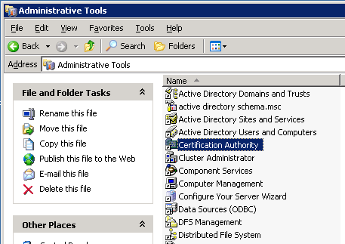

Open the Pending requests folder.

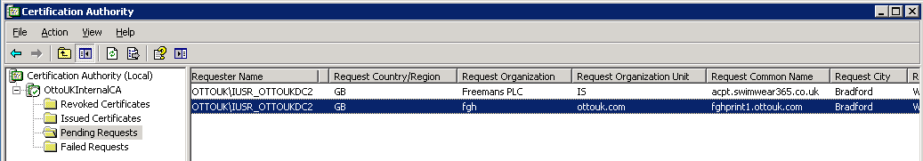

Highlight your request right click, all tasks and Issue the certificate.

Then go back to http://fghca0/certsrv/

Review your pending certificate and it will allow you to download it and save it to wherever you want.

Installing the Certificate

Go back to the server that you made the request on.

Open IIS

Click on Complete Certification request.

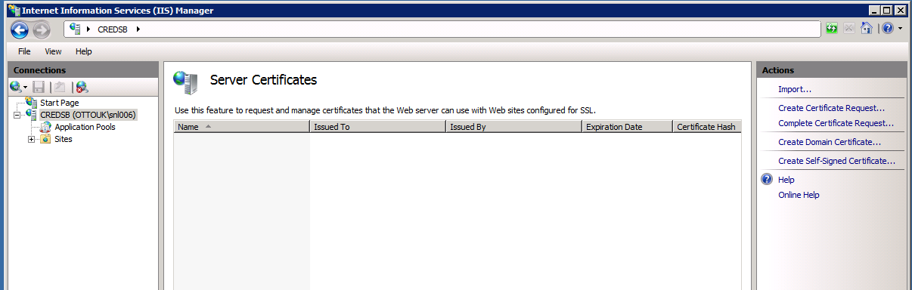

Browse to your cert file.

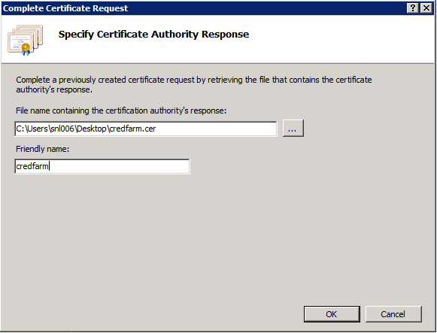

OK it.

Then you can use it for your RDp session as well by spedcifying the Digital Certificate.

Open remote Desktop Connection Manager.

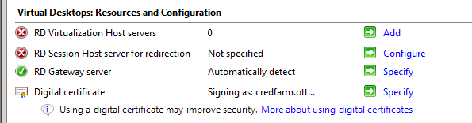

To use on other servers you need to export the certificate.

Right Click – Export.

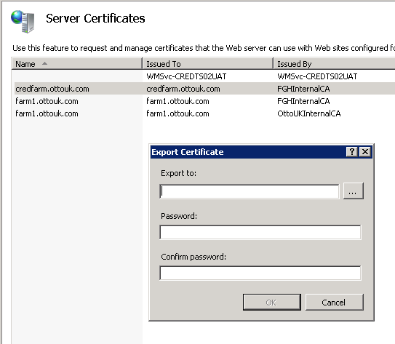

Specify a file path and password.

Export as a .pfx file.

# Import on new server

Open mmc and add the certificate snap in.

Import the certificate to the personal store.

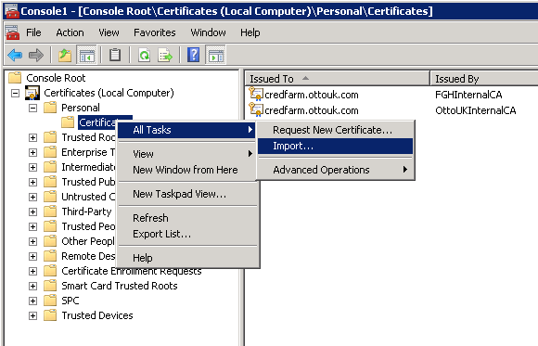

In the Wizard Browse to the pfx file.

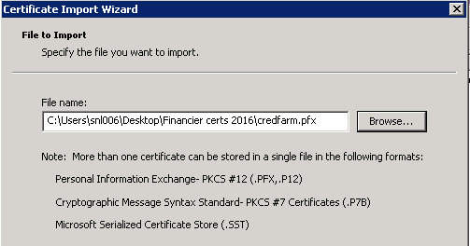

Enter the password.

Place the certificate in the personal store

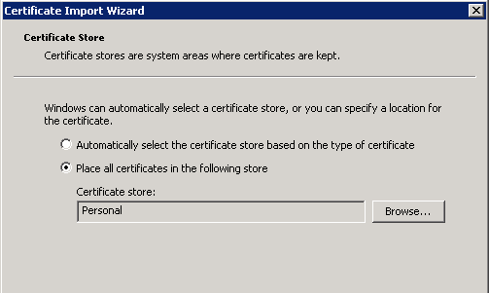

Finish.

Then open the Remote App Manager

Click on change Digital Signature settings..

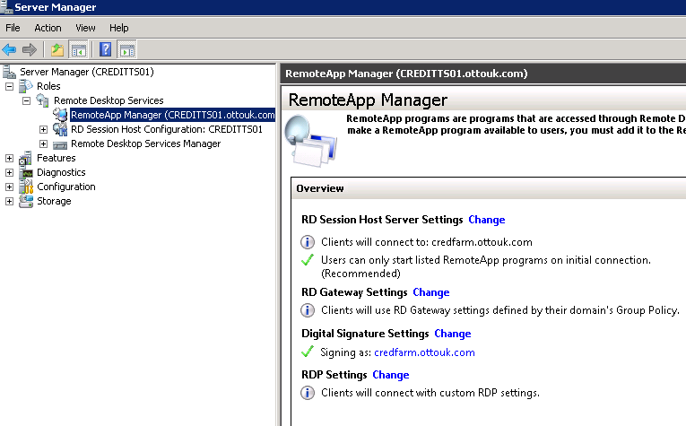

Check that it has the new certificate.

Then open RD Session Host Configuration

Select the General Tab of the RDP-TCP Properties.

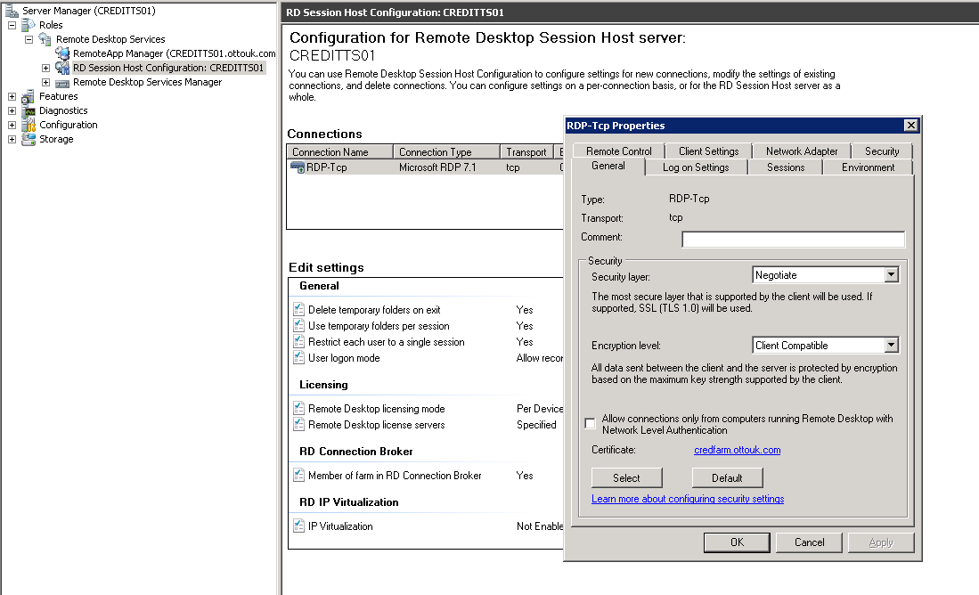

Select the new certificate.